Project Report

SOUL Management System
Designed for
School of Ultimate Learning

Submitted in partial fulfillment of the requirements for the award of degree of
Bachelor of Science
in
Computer Science
Submitted by
Saad Mughal
Muhammad Ismail Rana
Sheikh Muhammad Ibrahim
F2023-009
F2023-551
F2023-630

Submitted to
Dr. Natash Ali Mian
Assoc. Professor & HOD of Dept. Of Software Engineering



School of Computer & IT
Beaconhouse National University
Main Campus 13 KM Off Thokar Niaz Beg -
Raiwind Road, Tarogil, Lahore, Pakistan
Group Members


Saad Mughal
F2023-009


Muhammad Ismail Rana
F2023-551


Sheikh Muhammad Ibrahim
F2023-630

CONTENTS

Introduction 4
Company Overview 4
Proposed System 4
Data Requirements of the proposed system 5
EER Model 6
Relational Model 7
SQL 8
CREATE and USE statements: 8
CREATE table statements for all tables: 8
INSERT statements 12
UPDATE statements 17
DELETE statements 21
SELECT statements 23
Contribution 36
Experience 36
Conclusion 36

Introduction
In Today’s Digital Age, most organizations are transitioning to computerized systems to manage their operations efficiently. Similarly,educational institutions can greatly benefit from digital systems that streamline their administrative processes,especially as they handle a significant volume of data daily. This transition reduces manual effort while enhancing accessibility and transparency for all users of the system. So, a well-structured school management system empowers educators, simplifies processes, and enhances the overall learning experience. At the heart of any successful system lies a robust database model. This model serves as the digital blueprint, dictating how data is organized, stored, and accessed. Embracing data allows schools to become more innovative, adapt to changing educational needs, and prepare students for success in an increasingly data-driven world.

Company Overview
SOUL School, an Islamic school established in 2011 in Sheikh Da Kot, Bahria Town Lahore, is dedicated to providing a well-rounded education that integrates modern learning with Islamic values. As a non-profit organization, SOUL Schools aims to ensure access to quality education for students from diverse backgrounds, fostering both academic excellence and spiritual growth within an inclusive environment. While facing initial challenges and resource limitations, particularly in acquiring necessary computer equipment and infrastructure, SOUL Schools have consistently strived to elevate educational standards. Recognizing the critical need for a robust system to manage student and faculty records efficiently, they have recently proposed the implementation of a comprehensive database solution.

Existing System Overview
SOUL operates with a traditional and personalized approach to management, where students' enrollment and attendance are manually recorded in registers. The school supports children from all backgrounds by offering discounted fees or, in some cases, completely free education, depending on their needs. Fees are due on the first of every month, and a registration fee is required at the time of enrollment, ensuring an efficient admission process. The school offers grades from pre-nursery to the eighth grade.

Proposed System
The SOUL School Management System aims to digitize and streamline the enrollment, course management, fee handling, and attendance processes through a centralized and standardized platform. This system includes a robust database for storing student records, fee details, and attendance logs. The platform will provide role-based functionalities for Admin, Teachers, and Students. Although students from grades 1 to 8 will not have direct logins, their data and interactions will be managed by administrators and teachers on their behalf.
- Admin Role: Manages new student enrollments by assigning them to appropriate grades and sections. Admins oversee the creation and maintenance of fee structures, issue digital challans, and monitor fee payment statuses. They manage teacher assignments to classes and subjects, ensuring proper alignment with curriculum requirements. Admins are responsible for organizing sections, monitoring their strength, and addressing any capacity issues. Additionally, they oversee attendance management for all students and ensure accurate record-keeping of the academic and administrative system.
- Student Role: While students in grades 1 to 8 lack direct access to the system. Their profiles, attendance, and fee information will be managed by admins and teachers. Administrators can access student data and monitor attendance, fee status, and academic schedules on behalf of the students. Students will indirectly benefit from the organized schedule management, attendance tracking, and efficient administrative oversight facilitated by the system.
- Teacher Role: Manages and delivers subject-specific lessons to assigned classes and sections. Teachers maintain student attendance records and ensure accuracy in reporting. They evaluate student performance and provide feedback to both students and administrators. Teachers are responsible for preparing and updating lesson plans to align with the curriculum. They collaborate with administrators to address class and section-related issues and contribute to maintaining section strength. Additionally, teachers provide input on student behavior and progress, facilitating effective parent-guardian communication when needed.

Data Requirements of the proposed system

Soul Non-Profit School, an educational institution dedicated to providing quality education to students from all backgrounds, seeks a management system to facilitate efficient tracking and management of student profiles, teacher assignments, class structures, attendance records, and fee transactions. The system should maintain detailed student profiles, including a unique identifier (Student_ID), name (first name, middle name, last name), date of birth, address, contact details, guardian information, and the date of enrollment. Students can have multiple values for the contact and the address. The system will store teacher details using a unique Teacher_ID, including first name, middle name, last name, contact information and salary. Teachers are associated with multiple subjects they teach, and linked to their administrative overseer. Administrators are uniquely identified by Admin_ID, with additional attributes such as email, name, and role and each administrator oversees the specific section, fee transactions and teacher assignments. There can be many relationships between teachers and administrators allowing multiple associations as teachers can also be an administrator and vice versa. Also teachers can have multiple values as for the contacts and the classes in the school are identified using Subject_ID and class name. Each class can have multiple sections, represented by a unique Section_ID, and linked to specific teachers and administrators. Sections are characterized by their strength and administrative oversight (Admin_ID). There exists a multiple relationship between section and subjects for precise record-keeping. The school system tracks daily attendance for each student through an Attendance entity. Each record includes the Student_ID, attendance date, and attendance status (e.g., present, absent). Students may accumulate multiple attendance records, providing a comprehensive history for monitoring attendance trends providing a historical perspective on individual student participation.

EER Model

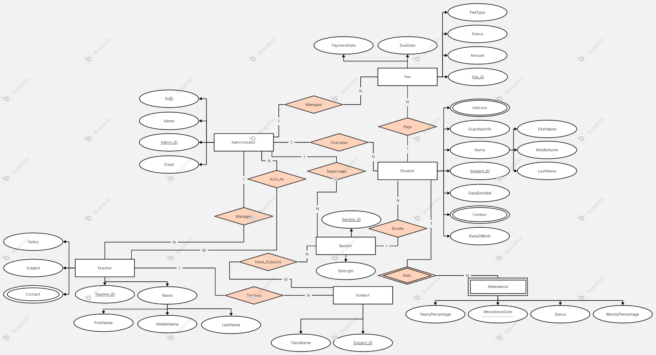

Relational Model

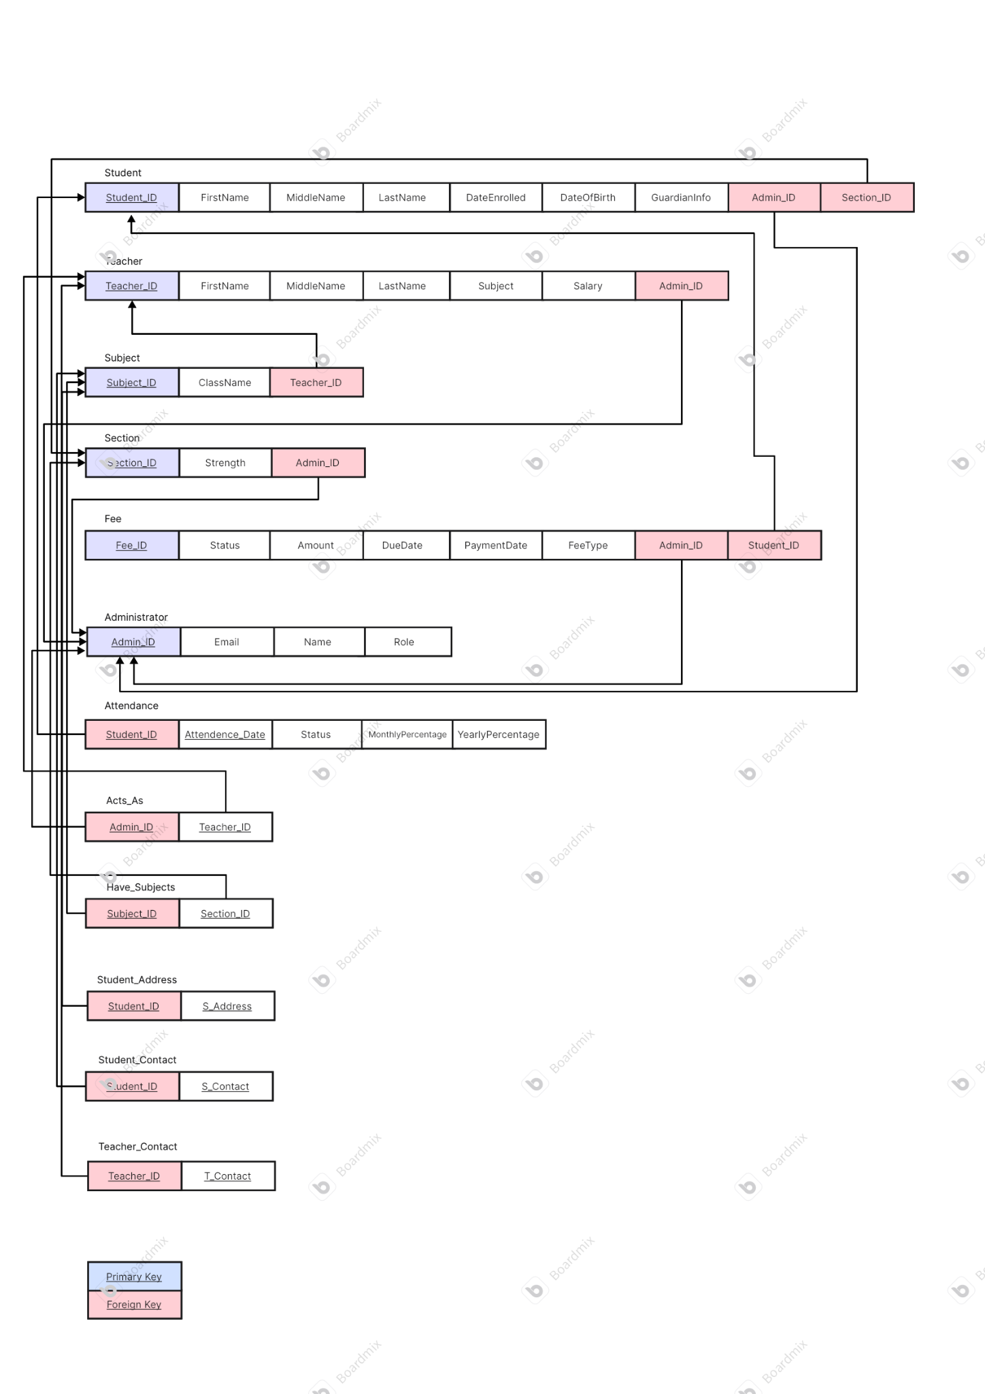

SQL

CREATE and USE statements:

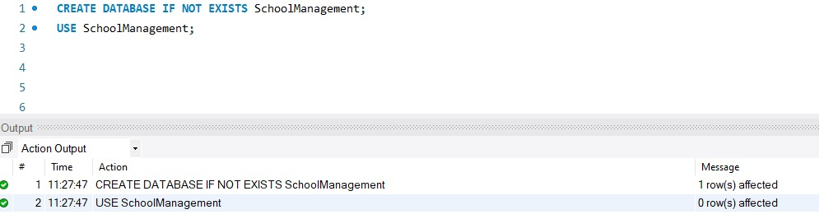

CREATE table statements for all tables:

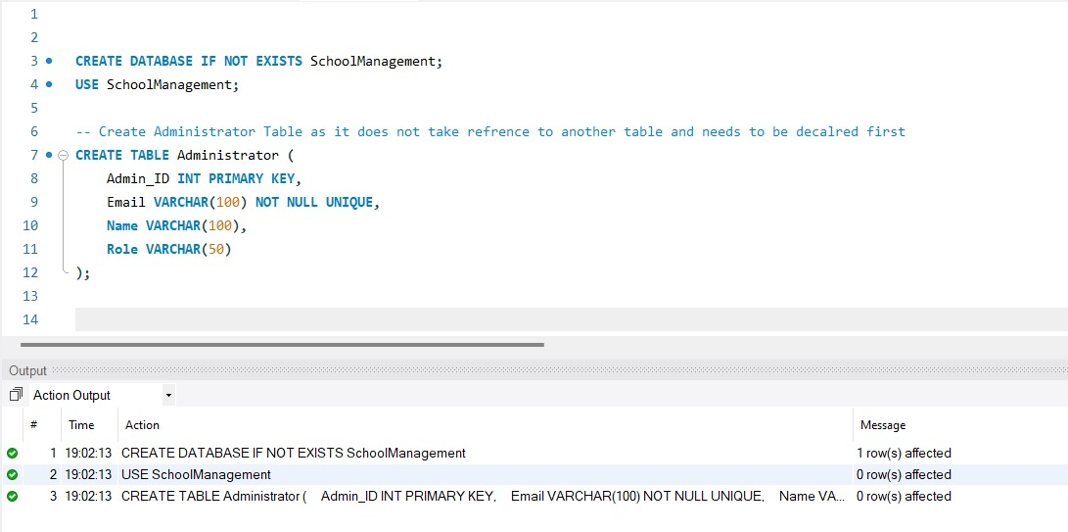
Fig 1: Create Administrator Table as it does not take reference to another table and needs to be declared.

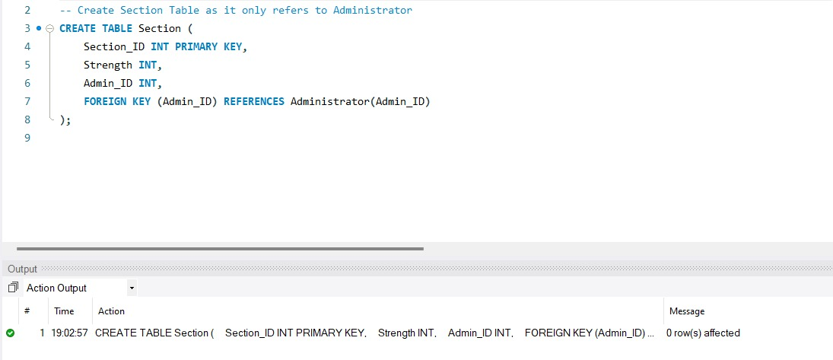
Fig 2: Create Section Table as it only refers to the Administrator table.

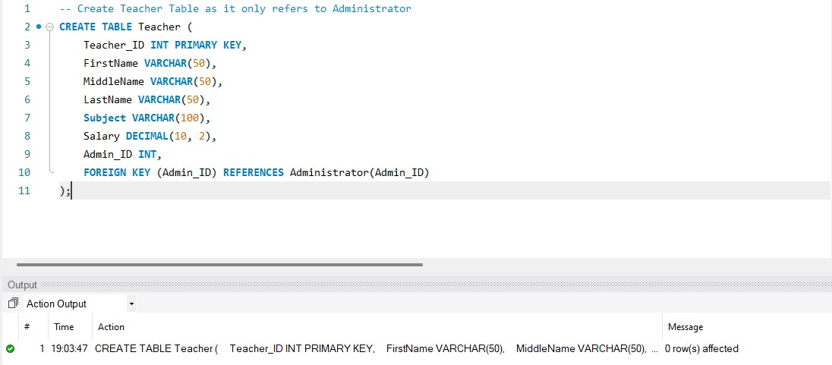
Fig 3: Create Teacher Table as it only refers to the Administrator.

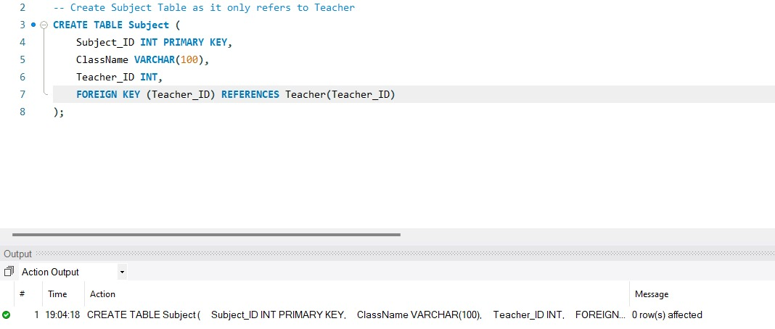
Fig 4: Create Subject Table as it only refers to the Teacher.

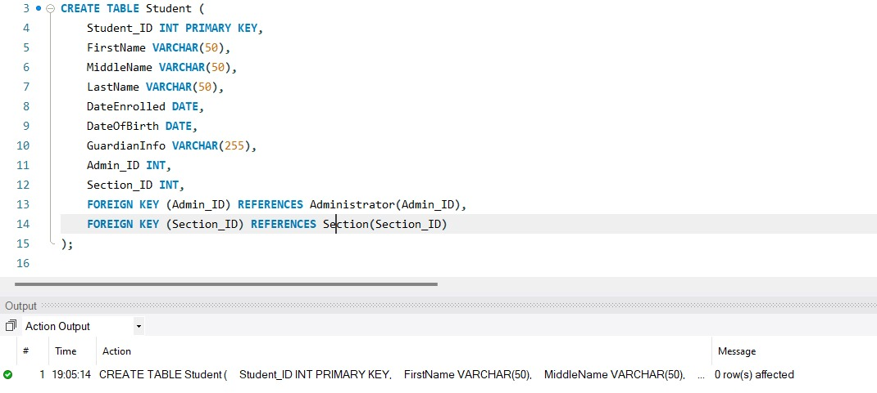
Fig 5: Create Student Table.

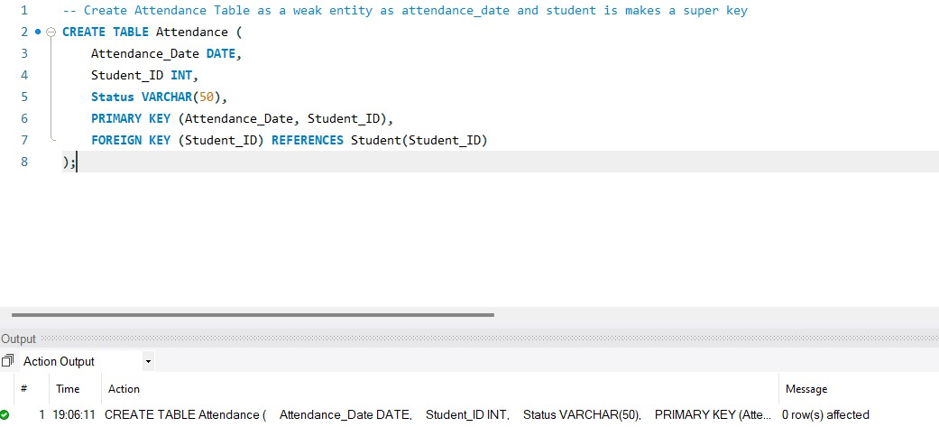
Fig 6: Create Attendance Table as a weak entity as attendance_date and student makes a super key.

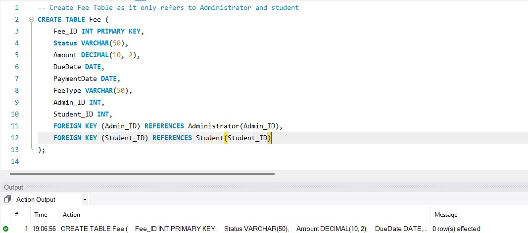
Fig 7: Create Fee Table as it only refers to Administrator and student.

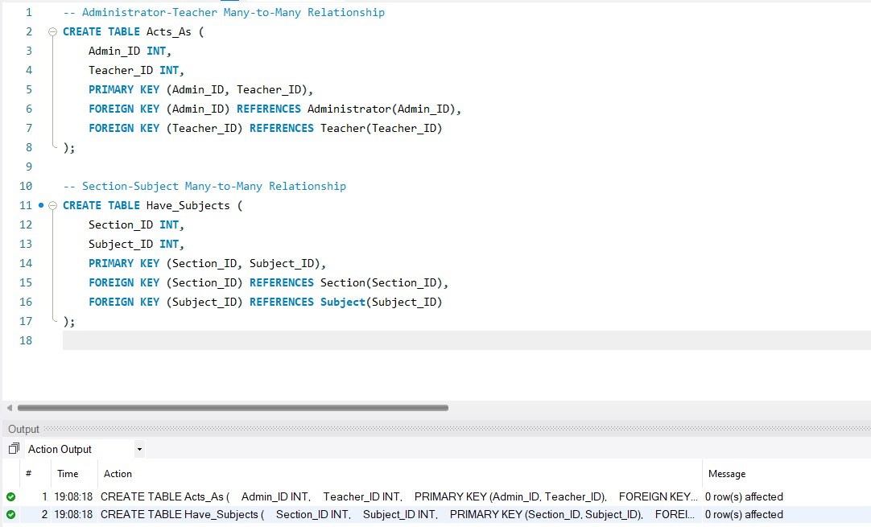
Fig 8: Create Administrator-Teacher Many-To-Many Relationship & Section-Subject Many-to-Many Relationship.

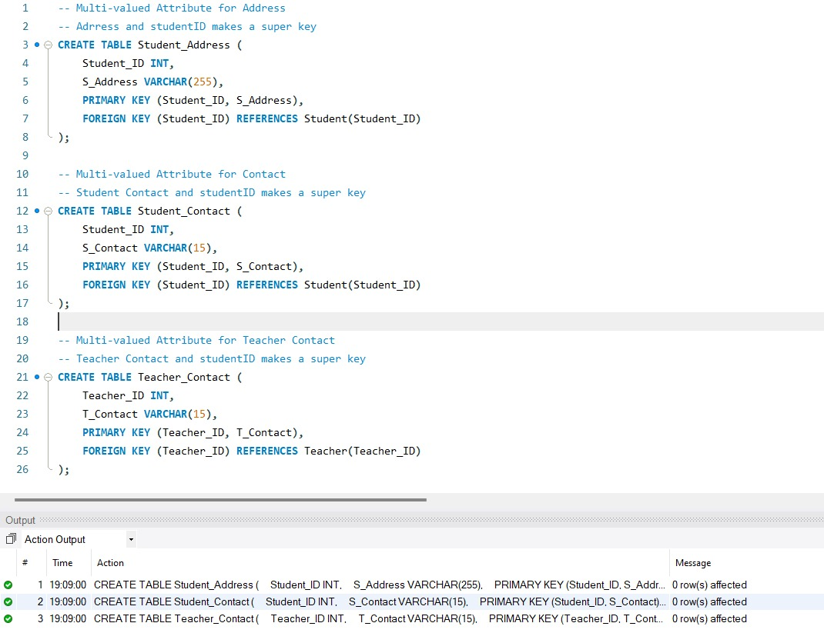
Fig 9: Multi-valued Attribute for Address, Address and studentID makes a super key.
Multi-valued Attribute for Contact, Student Contact and studentID makes a super key.
Multi-valued Attribute for Teacher Contact, Teacher Contact and studendID makes a super key.

INSERT statements

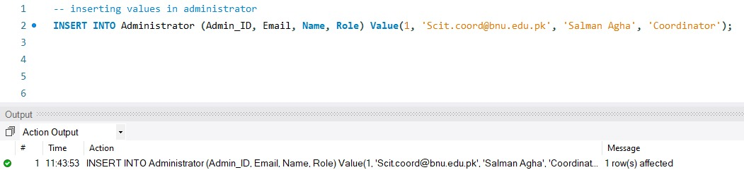
Fig 10: Inserting values in administrator.

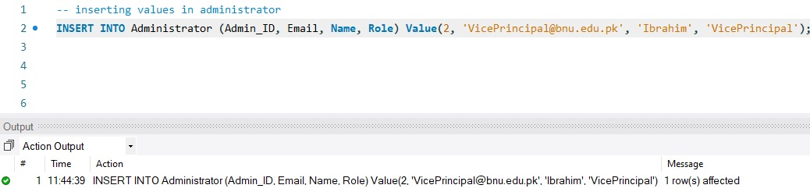
Fig 11: Inserting values in administrator.

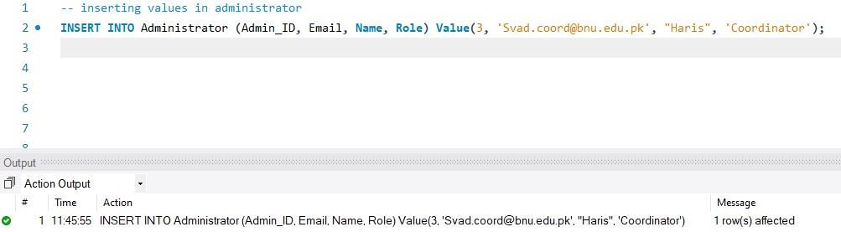
Fig 12: Inserting values in administrator.

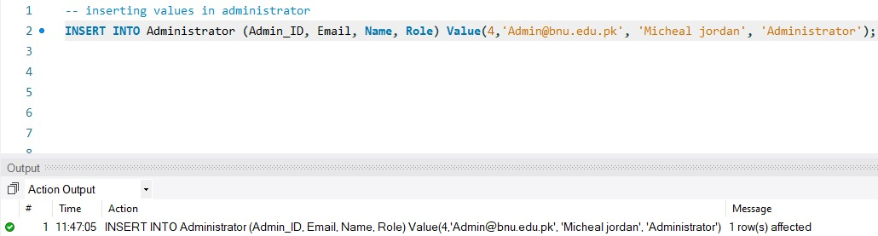
Fig 13: Inserting values in administrator.

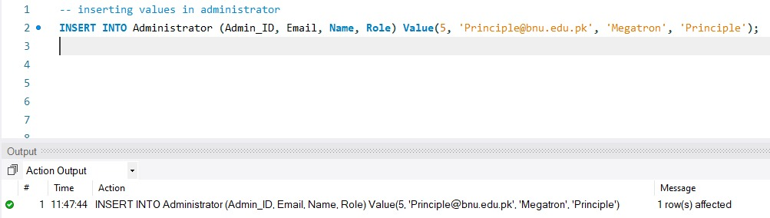
Fig 14: Inserting values in administrator.

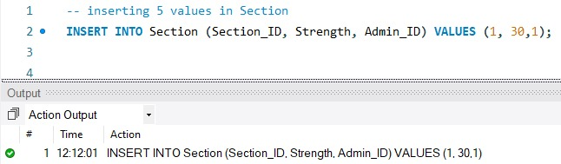
Fig 15: Inserting 5 values in Section.

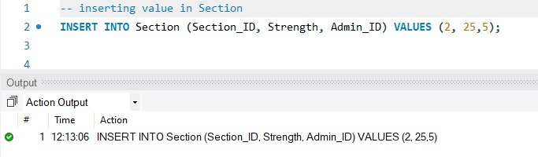
Fig 16: Inserting value in Section.

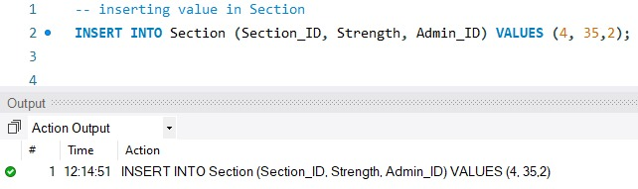
Fig 17: Inserting value in Section.

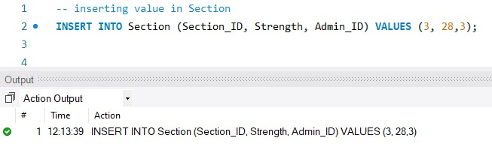
Fig 18: Inserting value in Section.

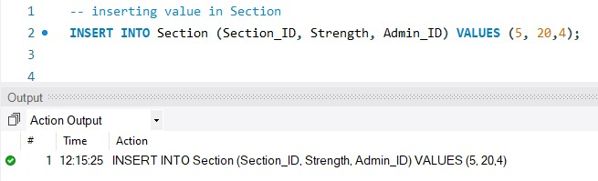
Fig 19: Inserting value in Section.

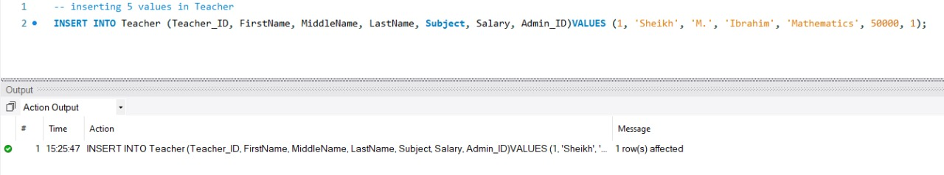
Fig 20: Inserting 5 values in Teacher.

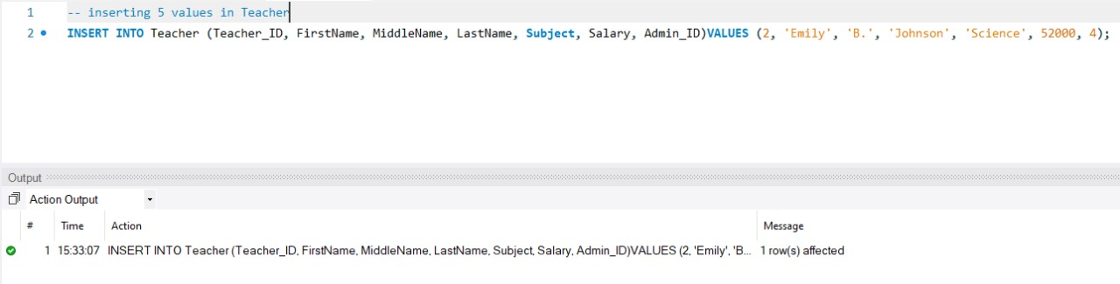
Fig 21: Inserting 5 values in Teacher.

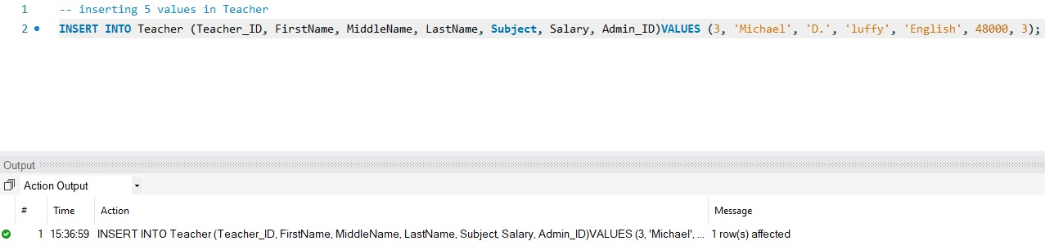
Fig 22: Inserting 5 values in Teacher.

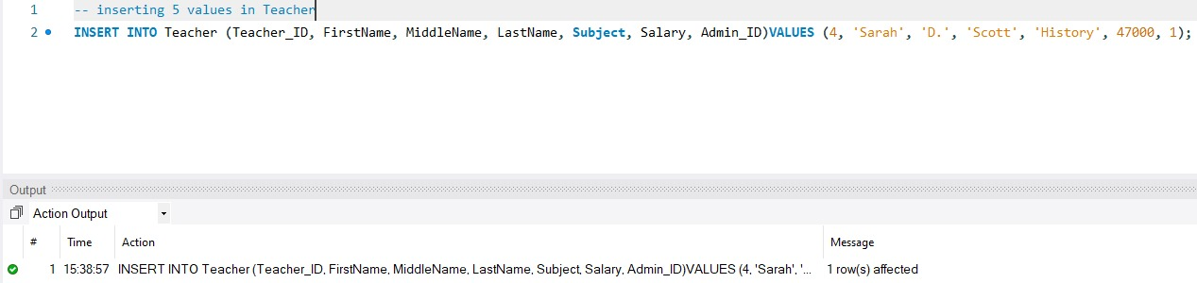
Fig 23: Inserting 5 values in Teacher.

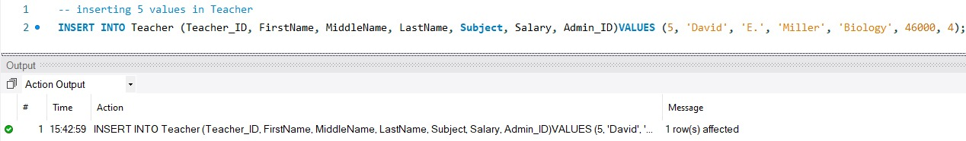
Fig 24: Inserting 5 values in Teacher.

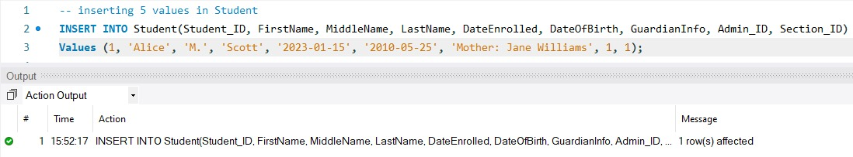
Fig 25: Inserting 5 values in Student.

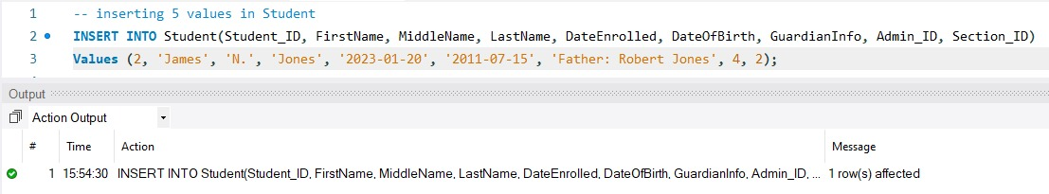
Fig 26: Inserting 5 values in Student.

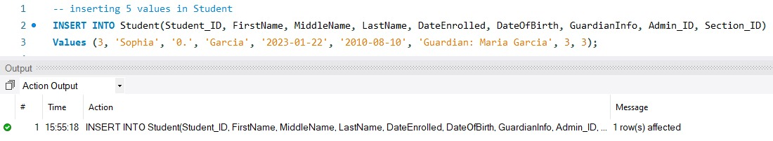
Fig 27: Inserting 5 values in Student.

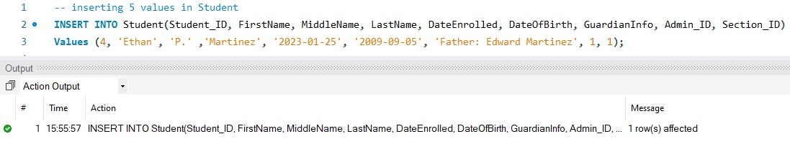
Fig 28: Inserting 5 values in Student.

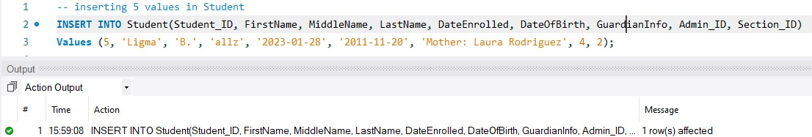
Fig 29: Inserting 5 values in Student.

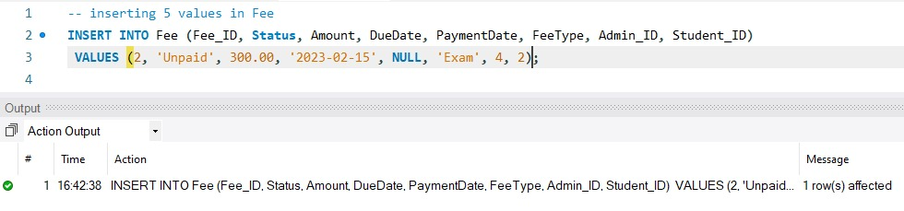
Fig 30: Inserting 5 values in Fee.

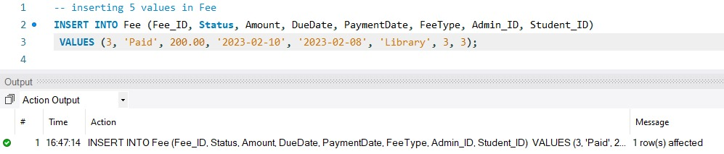
Fig 31: Inserting 5 values in Fee.

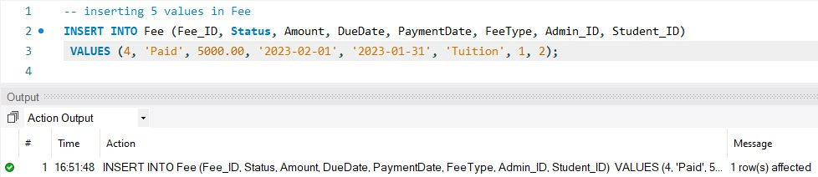
Fig 32: Inserting 5 values in Fee.

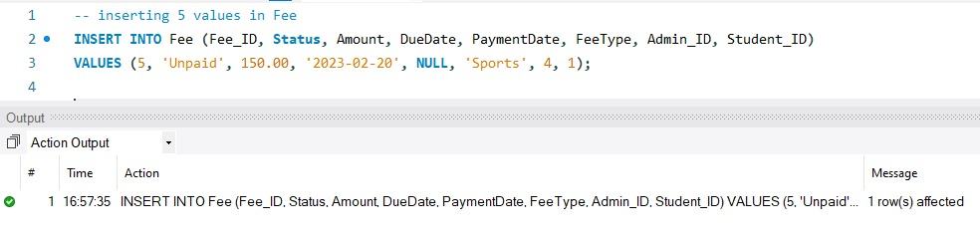
Fig 33: Inserting 5 values in Fee.


Fig 34: Inserting 5 values in Fee.

UPDATE statements

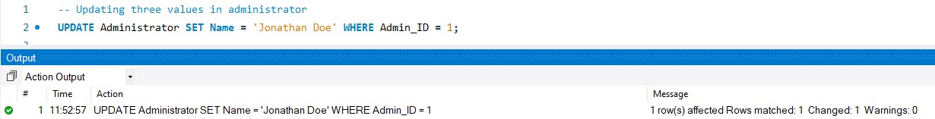
Fig 35: Updating three values in administrator.

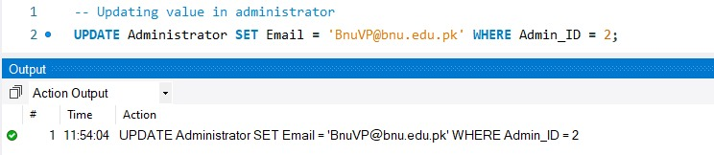
Fig 36: Updating value in administrator.

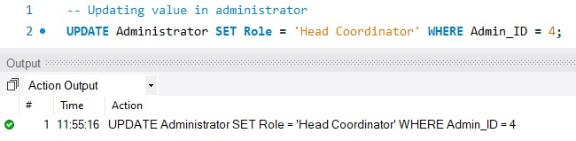
Fig 37: Updating value in administrator.

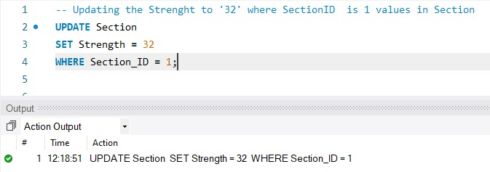
Fig 38: Updating the strength to ‘32’ where SectionID is 1.

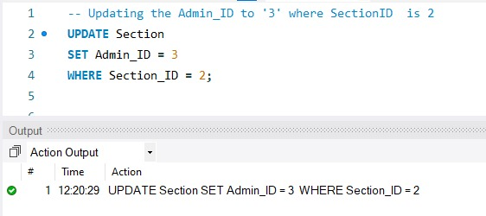
Fig 39: Updating the Admin_ID to ‘3’ where SectionID is 2.

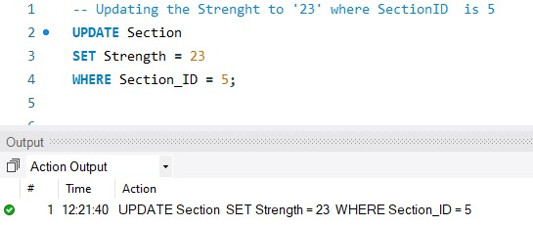
Fig 40: Updating the strength to ‘23’ where SectionID is 5.

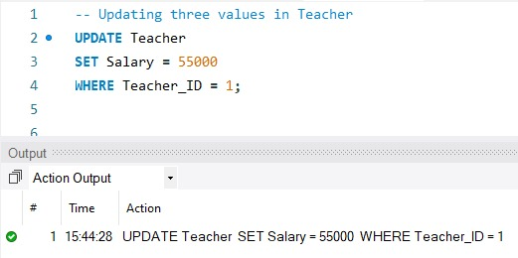
Fig 41: Updating three values in Teacher.

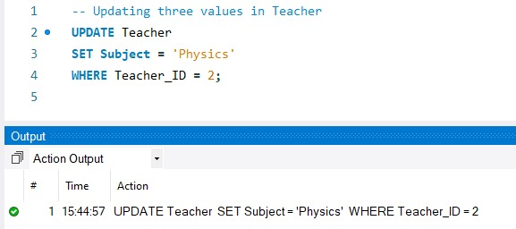
Fig 42: Updating three values in Teacher.

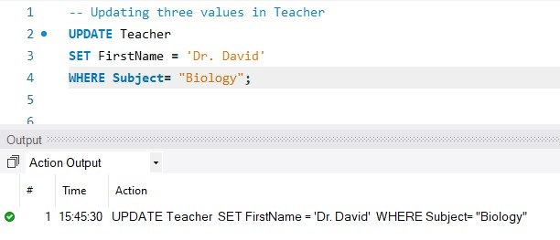
Fig 43: Updating three values in Teacher.

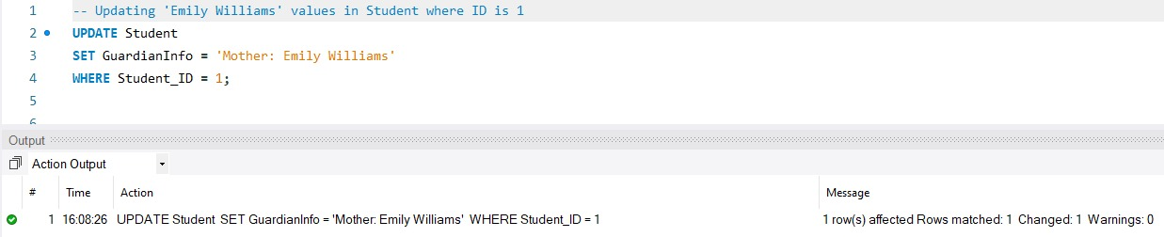
Fig 44: Updating ‘Emily Williams’ values in Student where ID is 1.

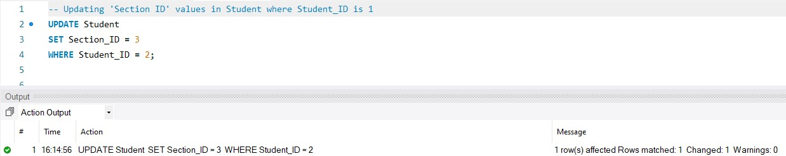
Fig 45: Updating ‘Section ID’ values in Student where Student_ID is 1.

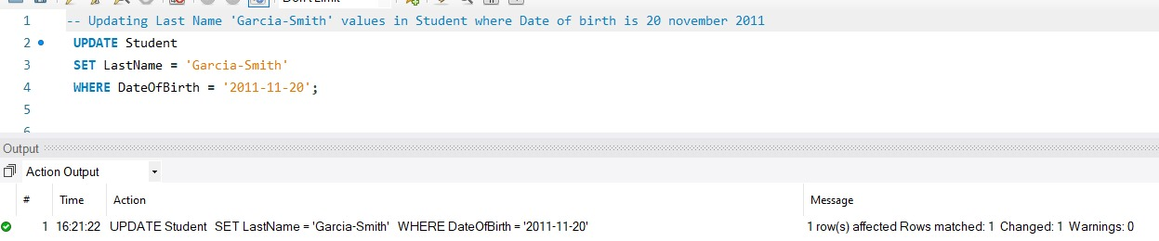
Fig 46: Updating Last Name ‘Gracia Smith’ values in Student where Date of birth is 20 november 2023.

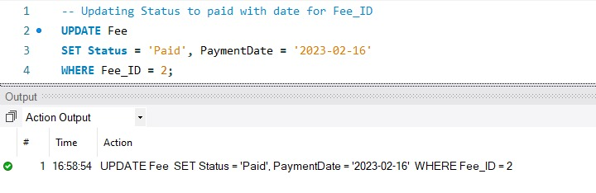
Fig 47: Updating Status to paid with date for Fee_ID.

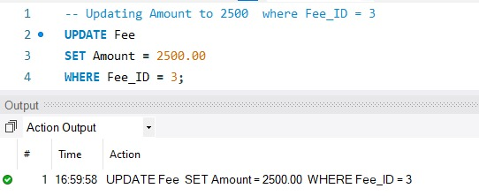
Fig 48: Updating Amount to 2500 where Fee_ID = 3

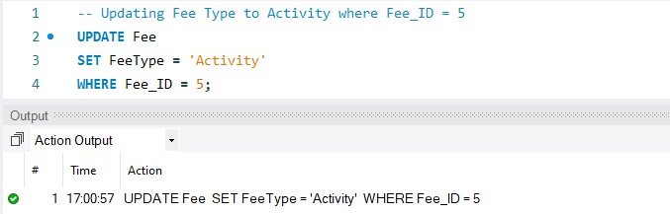
Fig 49: Updating Fee Type to Activity where.

DELETE statements
.
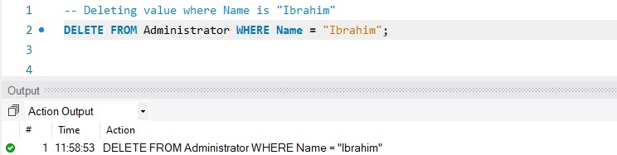
Fig 50: Deleting value where Name is “Ibrahim”.

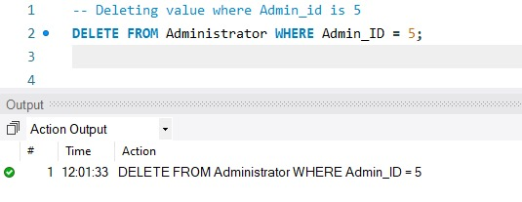
Fig 51: Deleting value where Name is “Ibrahim”.

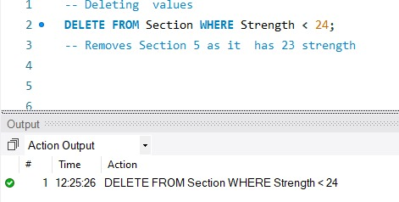
Fig 52: Removes section 5 as it has 23 strength.

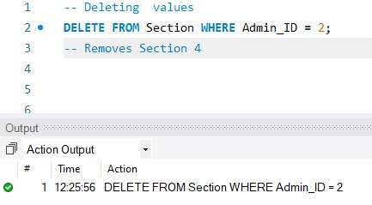
Fig 53: Removes section 4.

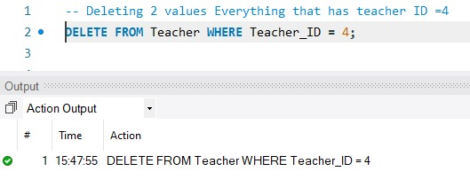
Fig 54: Deleting 2 values Everything that has Teacher_ID = 4.

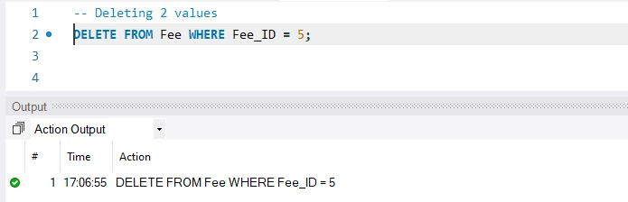
Fig 55: Deleting 2 values.

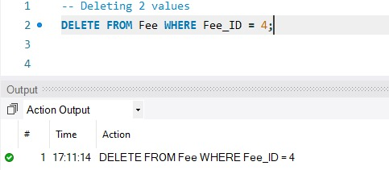
Fig 56: Deleting 2 values.

SELECT statements

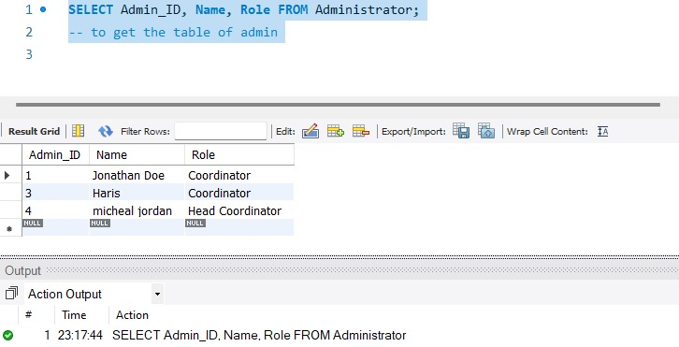
Fig 57: to get the table of admin.

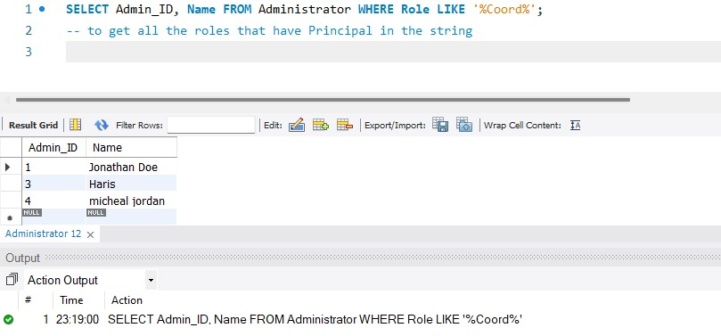
Fig 58: to get all the roles that have Principal in the string

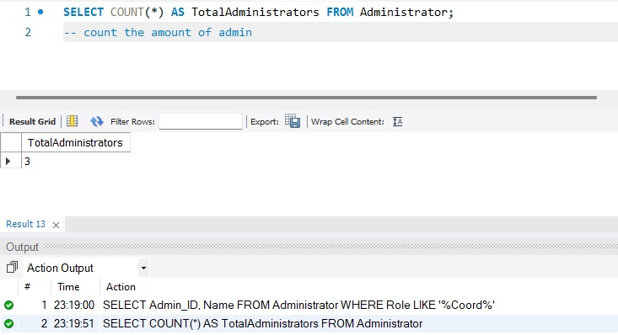
Fig 59: count the amount of admin.

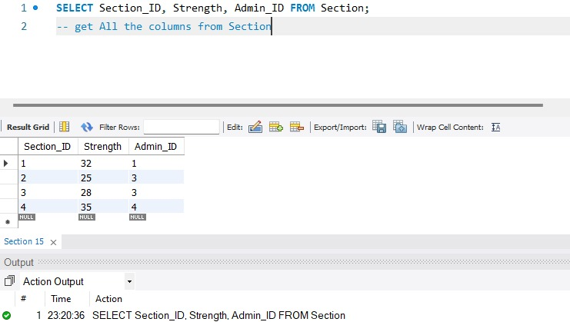
Fig 60: get All the columns from Section.

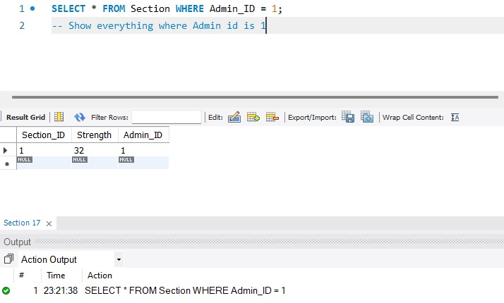
Fig 61: Show everything where Admin id is 1.

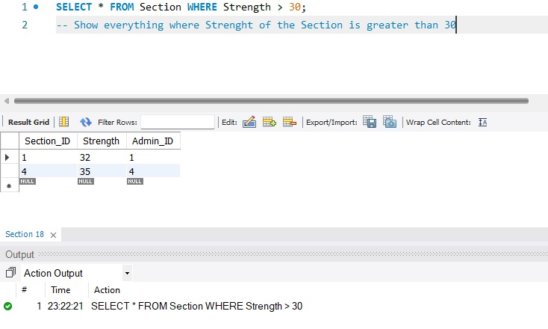
Fig 62: Show everything where Strength of the Section is greater than 30.

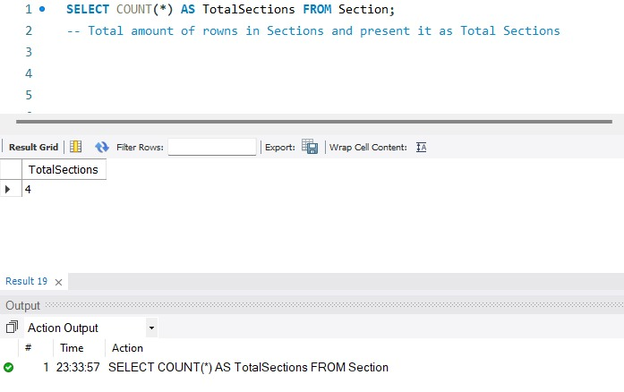
Fig 63: Total amount of rows in Sections and present it as Total Sections.

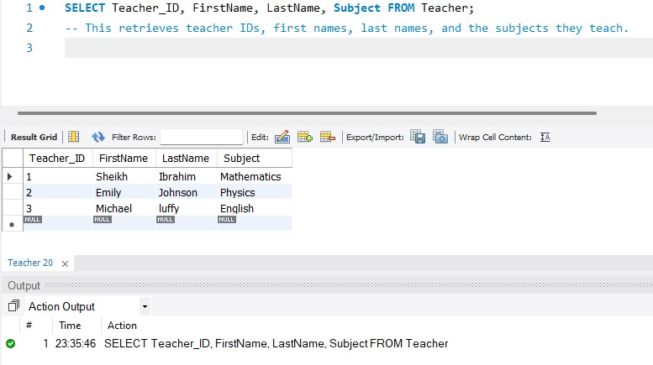
Fig 64: This retrieves teacher IDs, first names, last names, and the subject they teach.

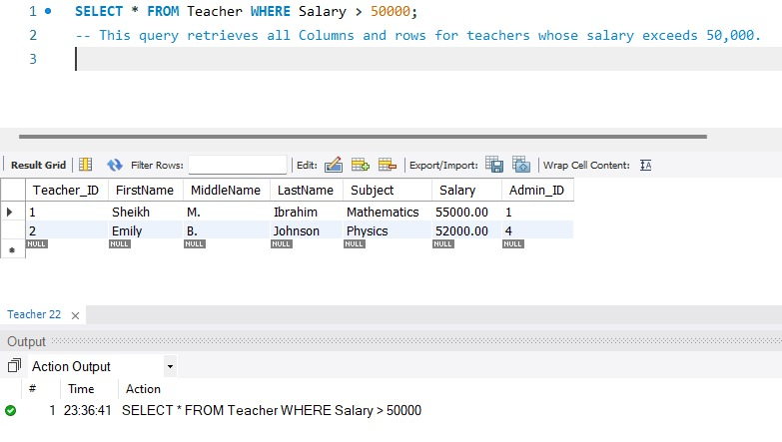
Fig 65: This query retrieves all Columns and rows for teachers whose salary exceeds 50,000.

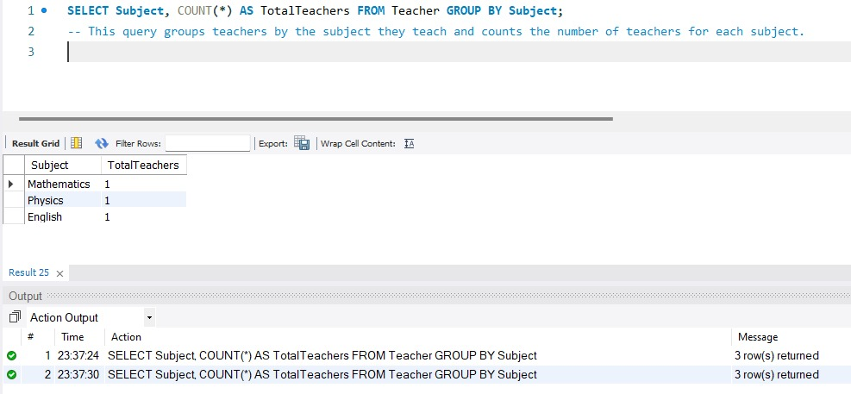
Fig 66: This query groups teachers by the subject they teach and counts the number of teachers for each subject.

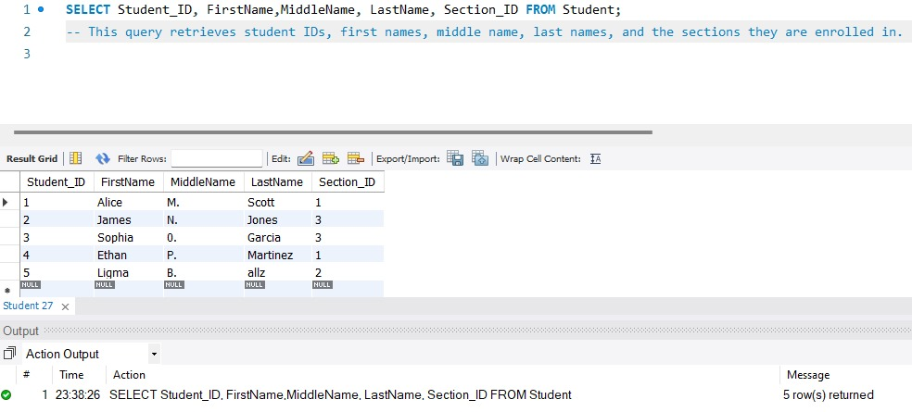
Fig 67: This query retrieves student IDs, first names, middle name, last names, and the sections they are enrolled in.

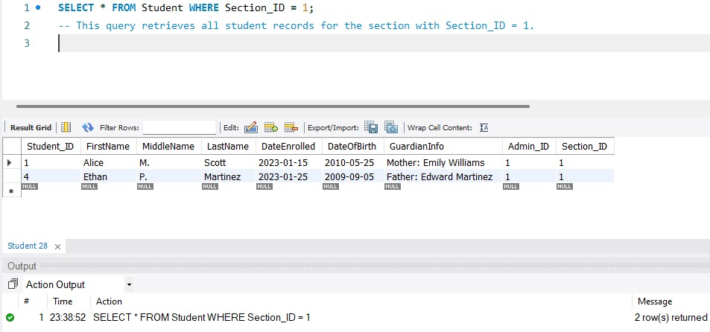
Fig 68: This query retrieves all student records for the section with Section_ID = 1.

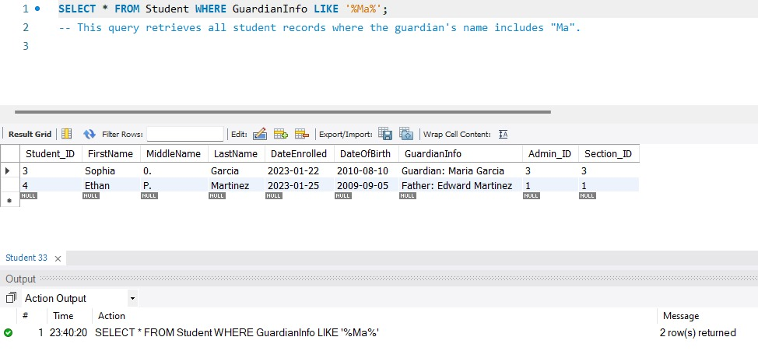
Fig 69: This query retrieves all student records where the guardian’s name includes “Ma”.

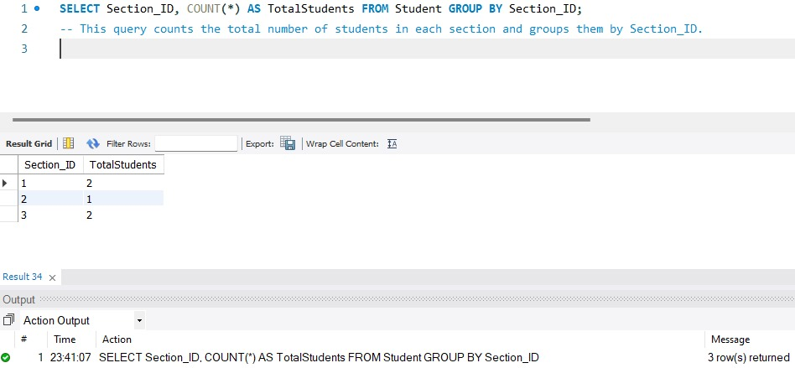
Fig 70: This query counts the total number of students in each section and groups them by Section_ID.

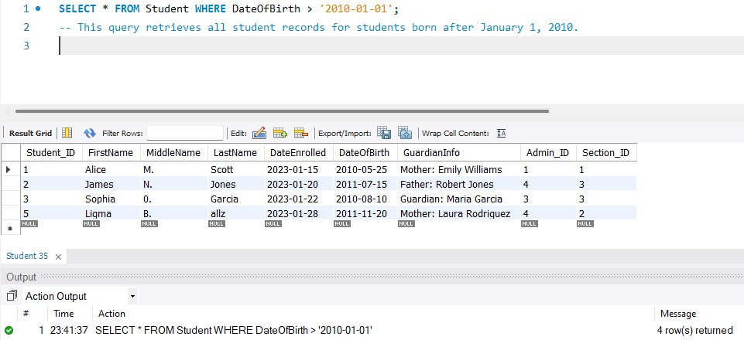
Fig 71: This query retrieves all student records for students born after January 1, 2010.

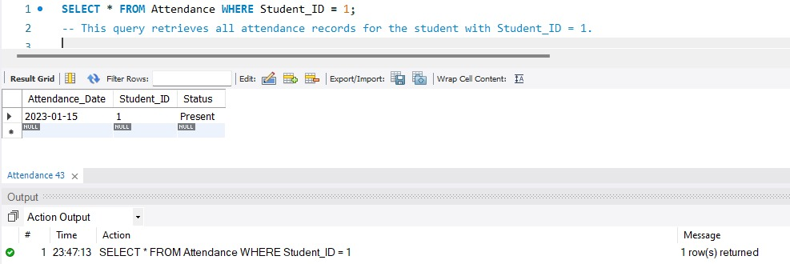
Fig 72: This query retrieves all attendance records for the student with Student_ID = 1.

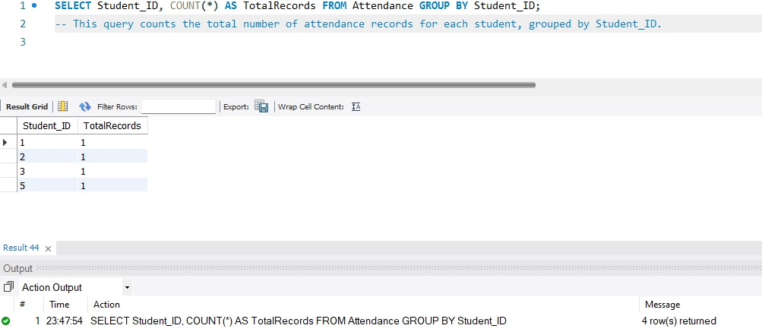
Fig 73: This query counts the total number of attendance records for each student, grouped by Student_ID.

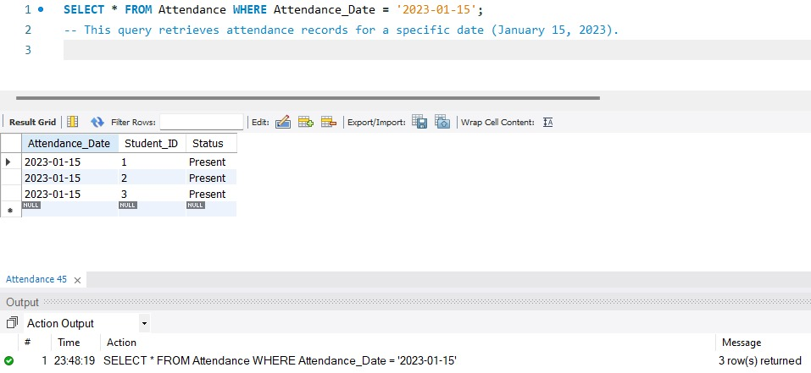
Fig 74: This query retrieves attendance records for a specific date (January 15, 2023).

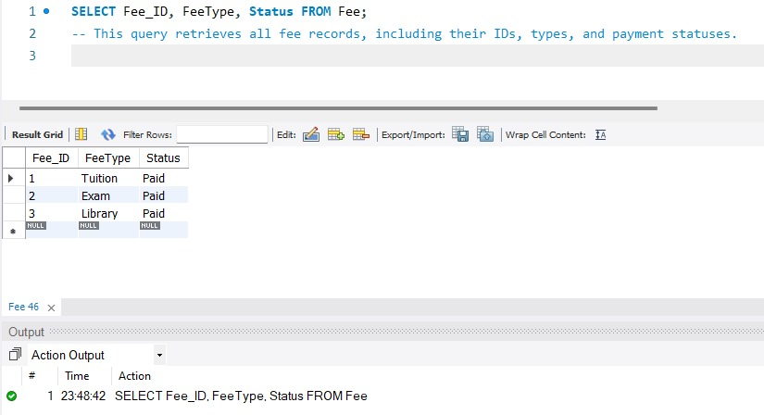
Fig 75: This query retrieves all fee records, including their IDs, types, and payment statuses.

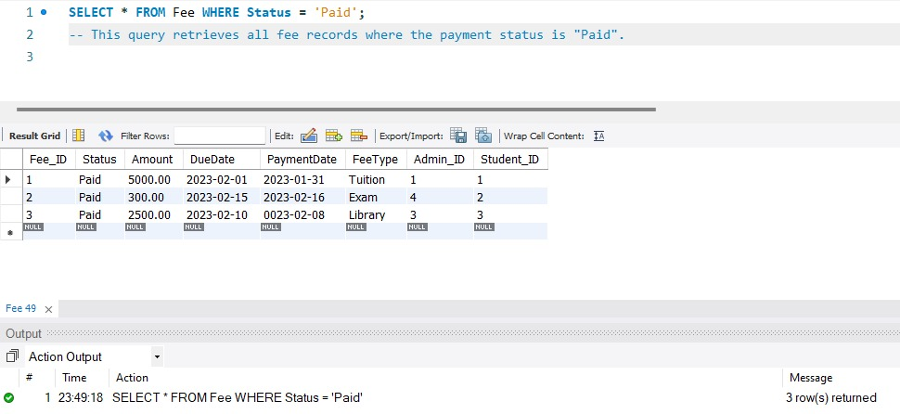
Fig 76: This query retrieves all fee records where payment status is “Paid”.

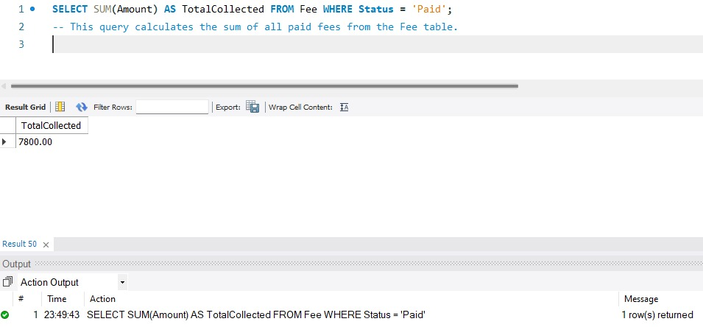
Fig 77: This query calculates the sum of all paid fees from the Fee table.

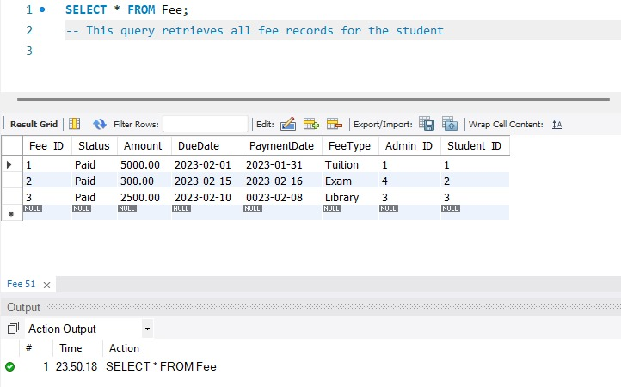
Fig 78: This query retrieves all fee records for the student.

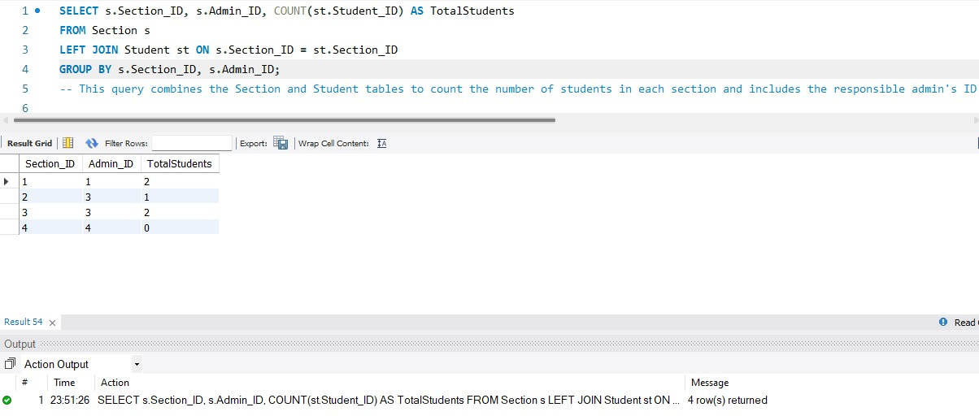
Fig 79: This query combines the Section and Student tables to count the number of students in each Section and includes the responsible admin’s ID.

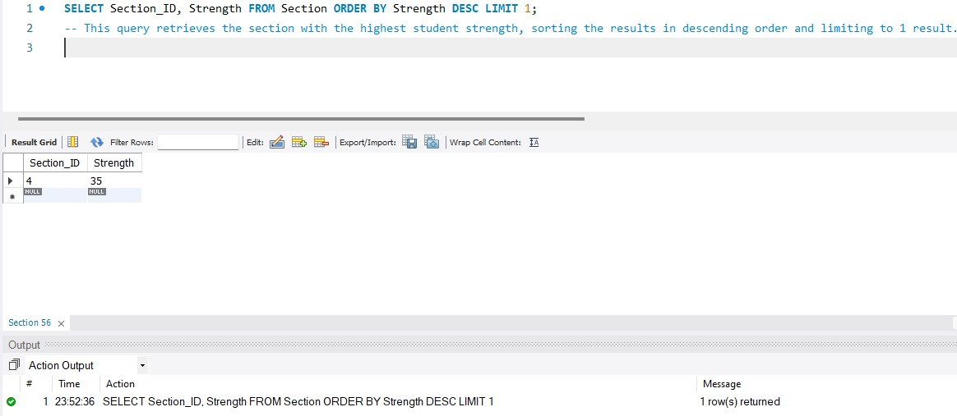Fig 80: This query retrieves the section with the highest student strength, sorting the results in descending order and limiting to 1 result.

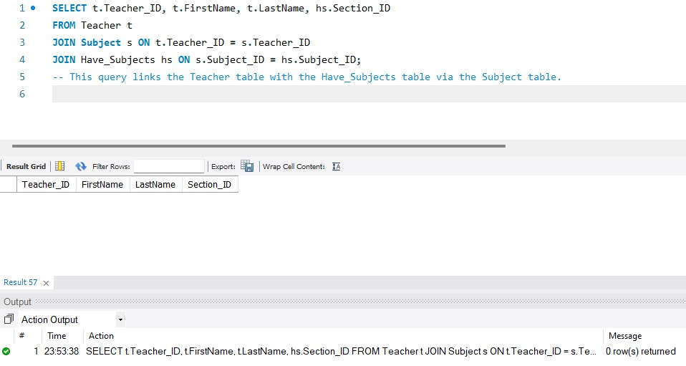
Fig 81: This query links the Teacher table with the Have_Subjects table via the Subject table.

Contribution
We have successfully transitioned a traditional school system into a fully digitalized and modern framework. By implementing a centralized school management system, we have streamlined critical processes such as enrollment, fee management, and attendance tracking. This transition not only reduces reliance on manual and paper-based methods also enhances operational efficiency and less chance of human error.
Our Project contributes to scalability by enabling the school to accommodate more students and staff without increasing administrative overhead. The reduction in paper usage aligns with sustainable practices, supporting environmental conservation efforts.

Experience
The development of a database model for a school management system provided a valuable learning experience. This project involved practical application of database design and implementation principles using tools such as MySQL. We began by constructing an Entity-Relationship (ER) diagram to visually represent the relationships between key entities within the school system, including students, teachers, courses, and grades. This ER diagram was then translated into a relational model, where we defined tables, columns, and established primary and foreign key relationships. This process underscored the significance of data normalization, a crucial step in ensuring data integrity and minimizing redundancy. By analyzing the complexities of managing student data, faculty information and attendance records, we recognized the critical need for efficient, automated systems within educational institutions. This project reinforced the importance of technology in modern education, enabling schools to streamline operations, improve data accuracy and management, and ultimately enhance the overall learning experience for us.

Conclusion
Reflecting on this project, it's clear that building a database model for a school management system transcends mere software development. This project has provided a valuable case study, demonstrating the challenges and possibilities that arise when technology is applied to solve real-world problems, particularly in the educational context. From conceptualizing the ER diagram to implementing the relational model, we experienced firsthand the iterative process of database design and the importance of considering factors such as data integrity, scalability, and user experience. This project has not only honed our technical skills but also cultivated a deeper appreciation for the role of technology in streamlining operations, improving efficiency, and ultimately enhancing the educational experience for all stakeholders. As we move forward, we will continue to explore innovative solutions and contribute to the evolving landscape of educational technology.

